Task 7: Load Balancers Types of load balancers.
1. In the AWS Management Console, launch two EC2 instances running a simple web server (use Amazon Linux 2 and install httpd or nginx), and verify both are accessible via their public IPs.
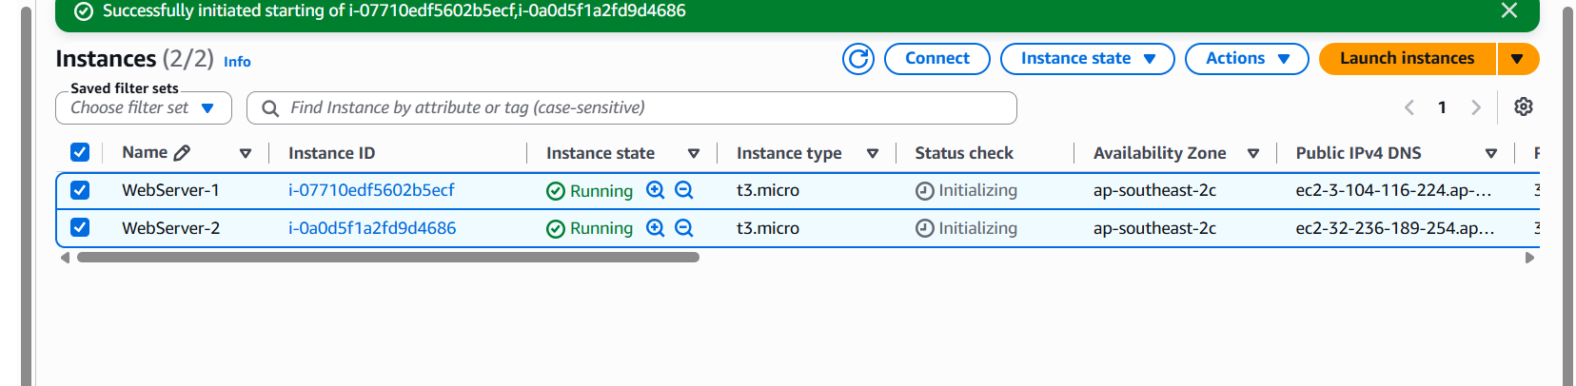

Sever-1
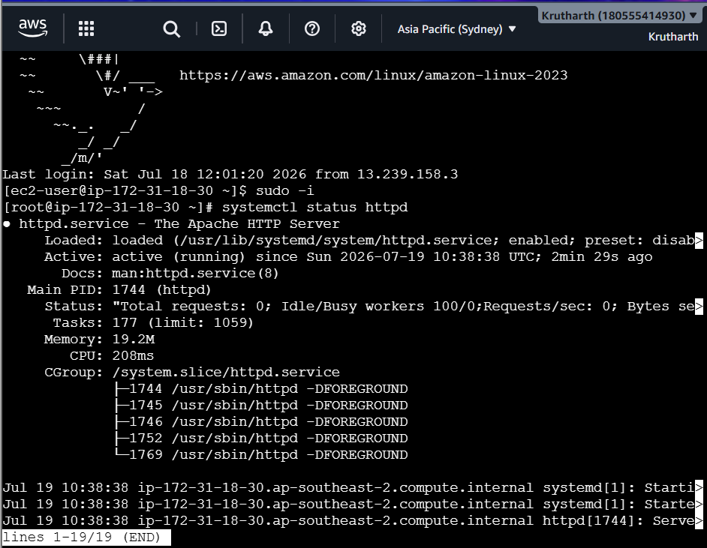
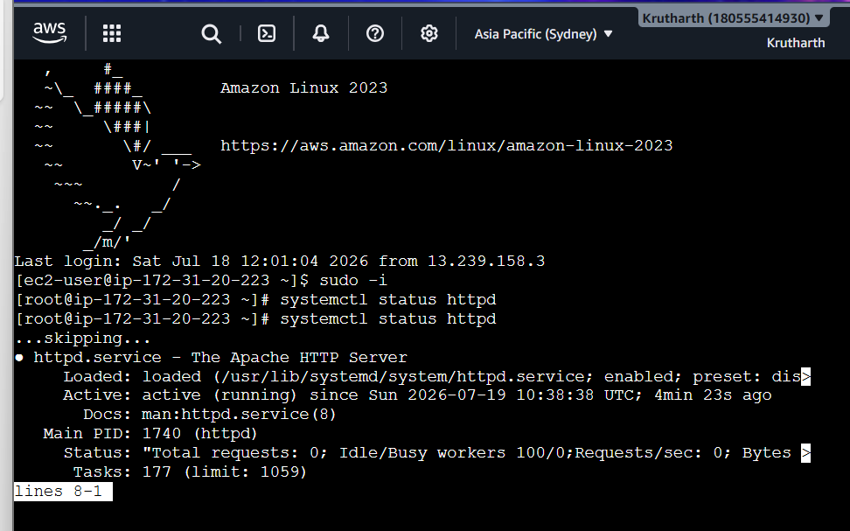



2. Set up an Application Load Balancer (ALB) in AWS that distributes incoming HTTP traffic across your two EC2 instances, and test by accessing the ALB's DNS name in your browser to see traffic served from both servers.
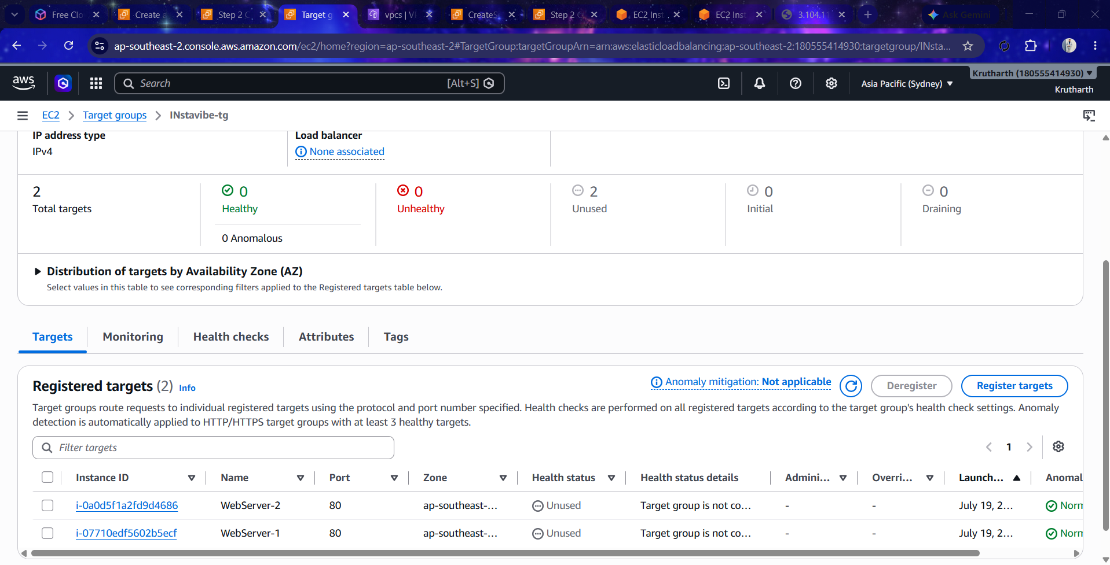

3. Change the health check settings of your ALB to use a custom path (e.g., /health) and verify that the load balancer only routes traffic to healthy instances.<br><br><em><strng>Hint:</strong> Create a /health endpoint on your web server that returns a 200 OK response.</em>
Create a health page.
Run on both servers.
echo "Healthy" | sudo tee /var/www/html/health
Verify.
http://<Server-IP>/health
Go to
Target Groups
Select the target group.
Choose
Health Checks
Edit
Health Check Path
/health
Save.
After a minute, both instances should become
Healthy
4. Simulate a server failure by stopping one of your EC2 instances and observe how the ALB handles requests — describe what happens and how this demonstrates high availability.
Ans: Stop WebServer-2. After approximately 30–60 seconds, the ALB health checks will detect that the instance is unhealthy and remove it from the target group. All incoming requests are automatically routed only to WebServer-1. Users continue to access the application without interruption because the load balancer sends traffic only to healthy instances. This demonstrates high availability and fault tolerance, ensuring the application remains accessible even when one server fails.
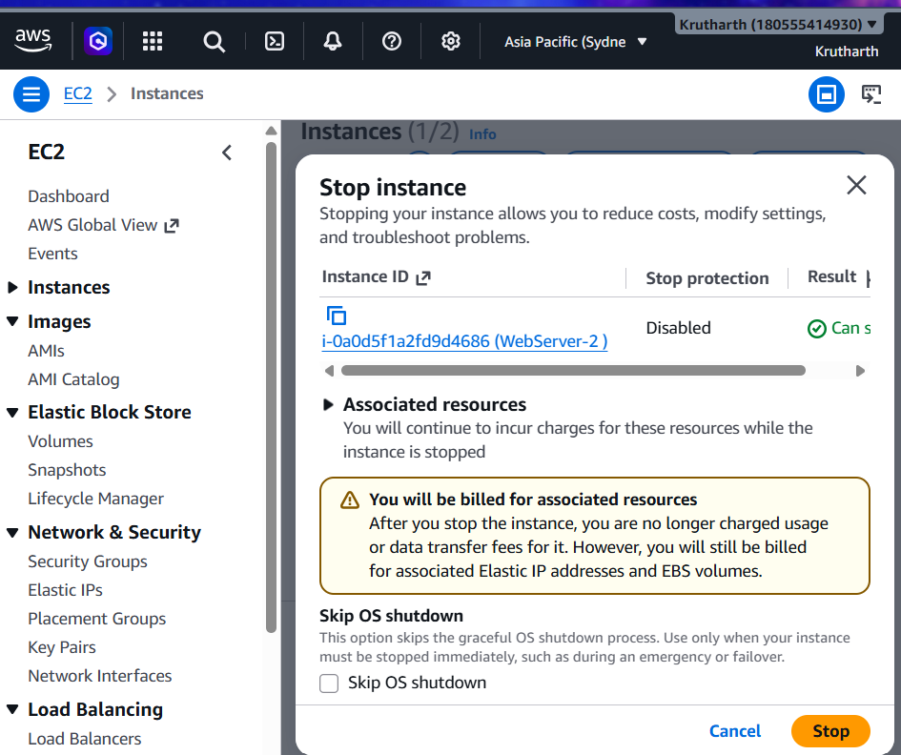
5. Compare Application Load Balancer, Network Load Balancer, and Classic Load Balancer in a table with at least 3 points each, focusing on supported protocols, use cases, and features.
Ans:
Feature | Application Load Balancer (ALB) | Network Load Balancer (NLB) | Classic Load Balancer (CLB)
Supported Protocols | HTTP, HTTPS, WebSocket, HTTP/2 | TCP, UDP, TLS | HTTP, HTTPS, TCP
OSI Layer | Layer 7 (Application Layer) | Layer 4 (Transport Layer) | Layer 4 and Layer 7
Best Use Case | Web applications, microservices, REST APIs | High-performance, gaming, VoIP, real-time applications | Legacy applications
Routing Features | Path-based and host-based routing | IP and port-based routing | Basic routing only
Performance | High | Very High with low latency | Moderate
Health Checks | Advanced and customizable | Basic | Basic
Target Types | EC2, IP addresses, Lambda functions | EC2 and IP addresses | EC2 instances only
Recommendation | Modern web applications | High-throughput and low-latency applications | Older AWS deployments (legacy)

